How to combine the order before payment?

1 log in your JLCPCB account. And upload your **first gerber file** , choose the PCB specifications.

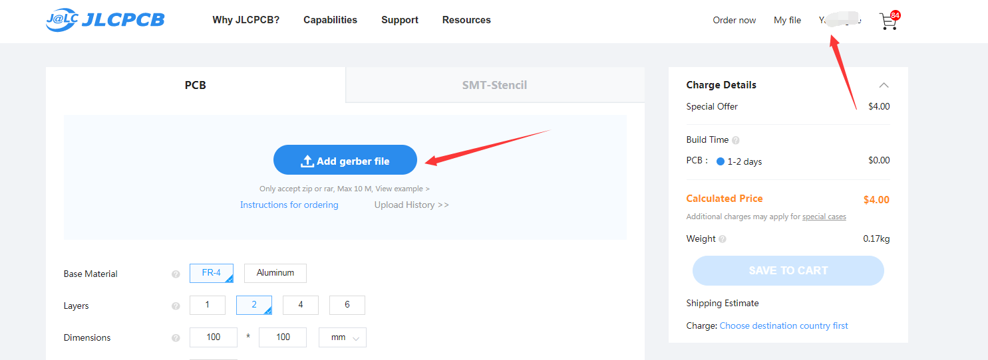2, Save the order to the cart , then you will see the View cart.

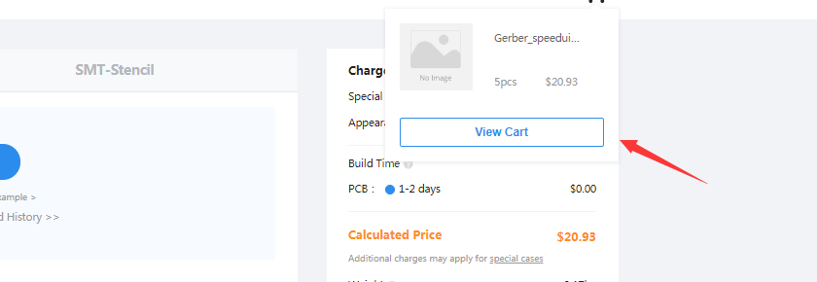

3, Click view cart, then find **add new item** button

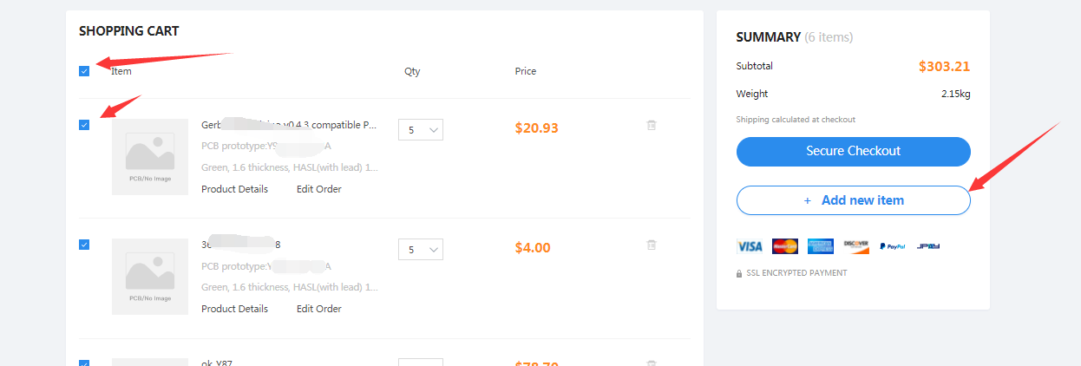

Then you will go back to the quote page again then you can upload the second order. If you want to combine a stencil order you can also choose the right side ,”SMT-Stencil” option.

